MUTUAL NON-DISCLOSURE/CONFIDENTIALITY AGREEMENT

THIS AGREEMENT dated as of ____________ between Flarecraft Corporation, a corporation organized under the laws of Delaware, with its place of business at Box 491, Avon, CO 81620 (the “Disclosing Party”), and______________________________________, with its principal office located at ___________________________________________________(the “Receiving Party”).

Whereas, it is essential for this purpose that the parties disclose certain technical and business information to each other which is proprietary and confidential (the “Information”); and

Whereas, each party wishes to ensure the protection and confidentiality of its Information:

Now, THEREFORE in consideration of the above, the parties hereto agree as follows:

1. The Receiving Party acknowledges that the Information is a special, valuable and unique asset of the Disclosing Party. The Receiving Party further acknowledges that disclosure of the Information would cause the Disclosing Party irreparable harm. The Receiving Party agrees, for itself and on behalf of its officers, directors, agents and employees, that it will keep in confidence all Information and that it will not directly or indirectly disclose the Information to any third party or use for its own benefit any Information it receives from the Disclosing Party in discussions and communications or through the performance of its duties. The Receiving Party agrees to use the same degree of care to protect the Information as it would employ with respect to its own Information of like importance which it does not desire to have published or disseminated. Additionally, the Information may be disclosed only to such of the Receiving Party’s employees who reasonably require access to such Information for the purpose for which it was disclosed. In case a subcontractor is the Receiving Party, it may disclose Information, to employees of companies which are owned or controlled, directly or indirectly, by the Receiving Party. Such disclosures will be subject to the same terms and conditions as appear in this Agreement.

2. The Information may be Information disclosed to the Receiving Party either orally, visually, facsimile, video conferencing, in writing (including graphic material), or by way of consigned items. When disclosed in writing, the Information will be labeled “CONFIDENTIAL”. When disclosed orally, visually, video conferencing, or by way of consigned items, such Information will be identified as “CONFIDENTIAL” at the time of disclosure with subsequent confirmation in writing by the Disclosing Party within fifteen (15) business days, referencing the date and type of Information disclosed. The Receiving Party agrees to clearly label as “CONFIDENTIAL”, all Information reduced to writing by Receiving Party as the result of, or arising out of, Information disclosures of Disclosing Party.

3. Information shall not be afforded the protection of this Agreement if it is:

(a) Publicly available prior to this Agreement or is made publicly available by the Disclosing Party without restriction;

- Rightfully received by the Receiving Party from a third party without accompanying secrecy obligations;

- Already in the Receiving Party’s possession and was lawfully received from sources other than the Disclosing Party;

- Demonstrated by the Receiving Party that it was independently developed by the Receiving Party; or

- Approved in writing by the Disclosing Party for release.

4. If any portion of any Information falls within any of the above exceptions, the remainder of the Information shall continue to be subject to the requirements of this Agreement.

5. Should the Receiving Party be faced with legal action to disclose Information received hereunder, the Receiving Party shall promptly notify the Disclosing Party, and upon the Disclosing Party’s request, shall cooperate with the Disclosing Party in contesting such disclosure.

6. All Information furnished hereunder shall remain the property of the Disclosing Party and shall be returned to the Disclosing Party or destroyed promptly at the Disclosing Party’s request together with all copies made thereof by the Receiving Party. As of the date of the Agreement, Receiving Party confirms it has none of Disclosing Party’s Information in Receiving Party’s possession. Upon request, the Receiving Party shall send the Disclosing Party a destruction certificate.

7. Except as provided herein, no right of license whatsoever, either expressed or implied, is granted to the Receiving Party pursuant to this Agreement under any patent, patent application, trademark, copyright, or other proprietary right, now or hereafter, owned or controlled by the representation, warranty, assurance, guaranty, or inducement by the Disclosing Party to the Receiving Party with respect to infringement of patent or other proprietary rights of others.
8. Information disclosed to the Receiving Party constitutes proprietary and intellectual property of the Disclosing Party. Accordingly, the use of the disclosed Information by the Disclosing Party, for present or future endeavors, is at the discretion of the Disclosing Party and is without encumbrances, restrictions, or constraints written or implied.

9. All notices hereunder shall be deemed to have been duly given upon the certified or registered mailing thereof, postage prepaid, to the other party at the address set forth above, unless such address is changed by written notice.

10. This Agreement shall be construed in accordance with, and governed, by the laws of the State of Delaware, with the exception of its provisions regarding conflicts of law.

11. The secrecy of the Information disclosed pursuant to this Agreement or prior to its execution shall be maintained for a period of five (5) years from the date of disclosure thereof.

12. Neither party shall, directly or indirectly, export, re-export, or transship products, technology, and software disclosed pursuant to this Agreement in violation of any applicable U.S. export control laws and regulations or any other applicable export control laws promulgated and administered by the government of any country having jurisdiction over the parties or the transaction(s) contemplated herein.

13. This Agreement embodies the entire understanding between the parties hereto respecting the subject matter hereof. No Agreement or understanding to modify this Agreement shall be binding upon either party unless in writing and signed by both parties.

IN WITNESS HEREOF, the parties have duly executed this Agreement.

Flarecraft Corporation _____________________________________

By: 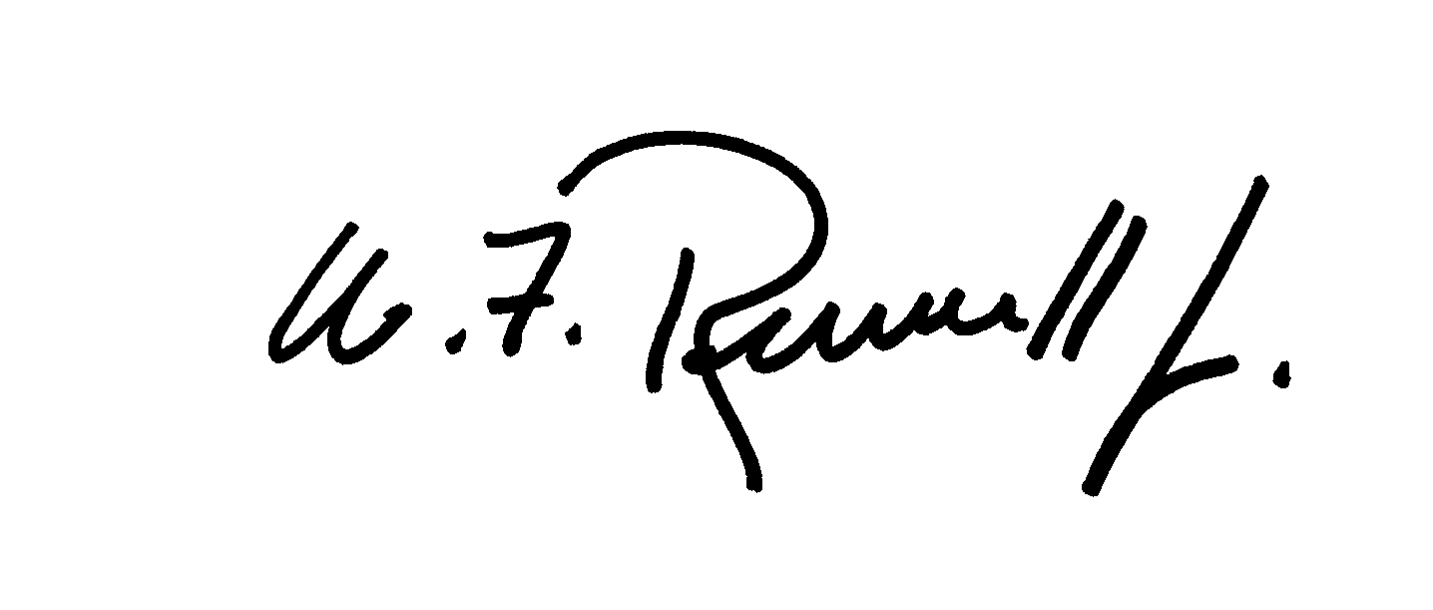 By: __________________________________

Name: William F. Russell, Jr. Name: _______________________________

Title: President Title: ________________________________

